

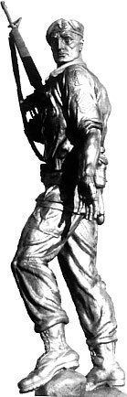***SPECIAL FORCES ASSOCIATION***

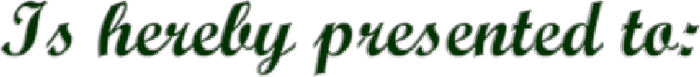

Cadet XXXXX

In keeping with the Traditions and Ideals of the United States

Army Special Forces Soldier’s Knowledge, Proficiency, Leadership, And Dedication to Mission, during the year 2024 - 2025 as a Cadet of

**XXXXXXX State University ROTC Program**

